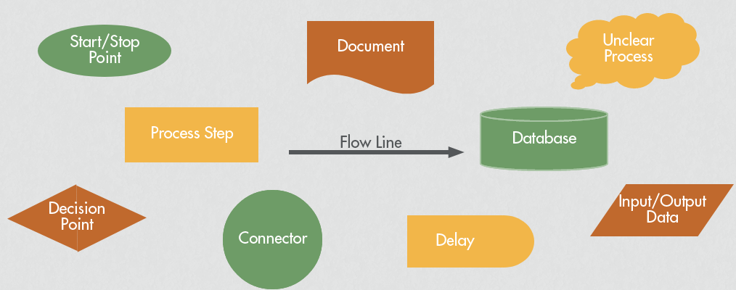
Process Map Symbols:

Process Maps can be used to identify improvement opportunities by:

Examining your process map and asking:
- Are there unnecessary steps?
- Where can you remove a step?
- Where are the “pain points”
- Can steps be combined?
- Done in different order?
- Done elsewhere?
- Done by someone else more effectively / efficiently?
- Done in parallel instead of sequentially?

Looking at the handoffs for opportunities to:

- Reduce Bottlenecks
- Reduce Delays
- Remove Duplication and/or unnecessary steps
- Link steps to remove gaps in flow

Looking at how the work gets done to:

- Eliminate rework
- Standardize practice to reduce variation in practice
- Improve steps that are prone to error

